10 things I like about Four51

Built as cloud-based, API-first, headless eCommerce platform, Four51’s Ordercloud offers vast amount of customization and endless storage solution while maintaining consistent and uniform data and structure throughout.

Here is a quick summary of 10 things I like about Four51.

# Headless

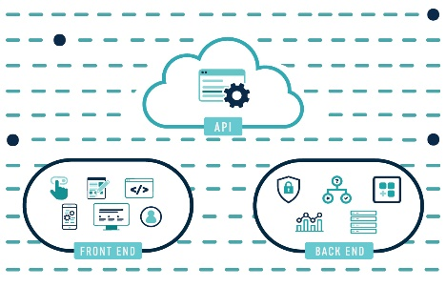Being headless is a huge plus nowadays with technology improving and companies growing their capabilities. Having a perfect front-end by not having one is one of the greatest strengths of Ordercloud. You can customize your front-end to your heart’s content without risking performance as front-end is completely independent.

# API-First

RESTful API being the building block of commerce data, you can quickly and easily integrate with your own system or other services. All your data can be accessed through REST API regardless of your integration system. This makes it quite easy to switch between systems or services if ever need be.

# Cloud, Cloud, Cloud

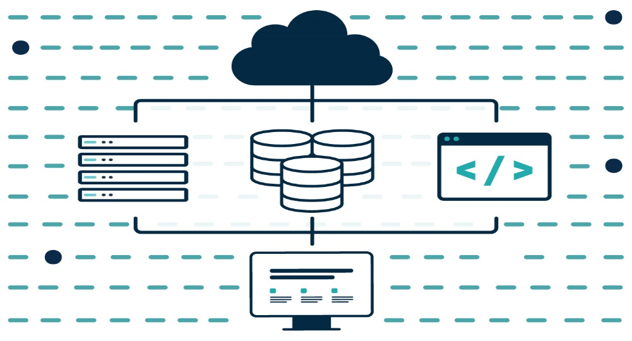With Ordercloud, everything is in cloud. Both development and delivery are cloud-based. This means it can scale automatically without having to worry about server infrastructure like with on-premises. Even a very small business can startup and as the business grows, so does your cloud.

# Microservices

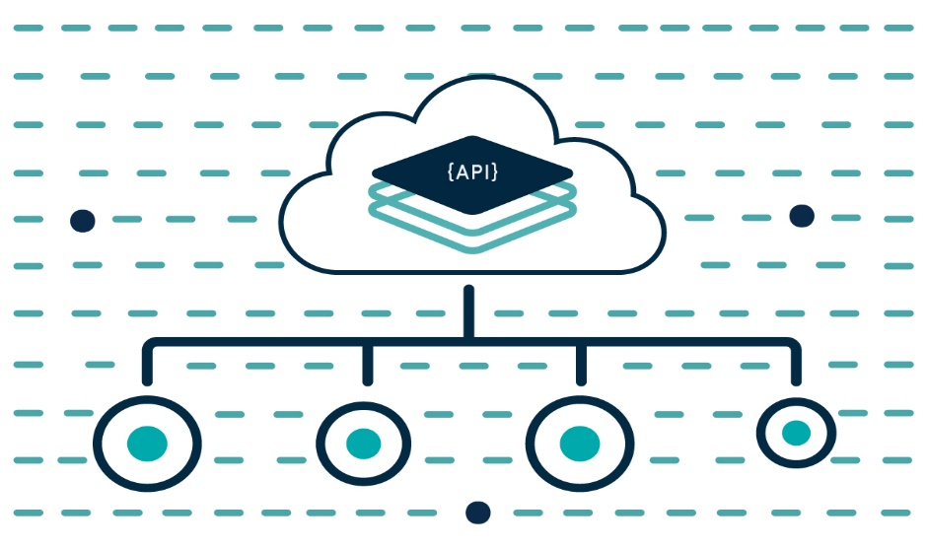In this age, microservices is proving to be quite useful. Best solutions are not built from scratch, but rather they are assembled with best parts. Ordercloud integrates with microservices seamlessly, making Four51 one of my favorite B2B eCommerce and Order Management provider.

# Security

Four51’s Ordercloud is annually audited for SOC Type 2 with HIPAA controls, and is compliant with GDPR and CCPA and facilitates PCI compliance for its platform and all solutions. This means no matter where your business serves its client’s, Four51 has you covered for all regions around the world.

# Language of Choice

This is by far my favorite feature of Four51. Developer can choose from their choice of tech stack for development without having to worry about compatibility. Pretty much all modern frameworks are designed to work well Out of The Box (OOTB) with JSON data and RESTful parameters. It is all JSON with Ordercloud.

# Webhooks

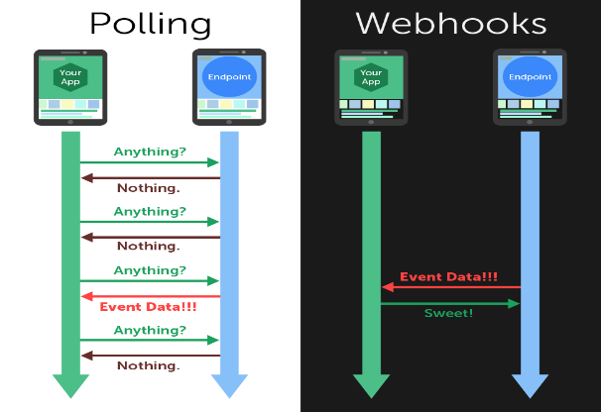The OrderCloud API supports user-defined HTTP callbacks, known as webhooks. These can be registered at Organization level or for specific application. You can pretty much hook into any event and perform your customization to suit your needs.

# Extended Properties

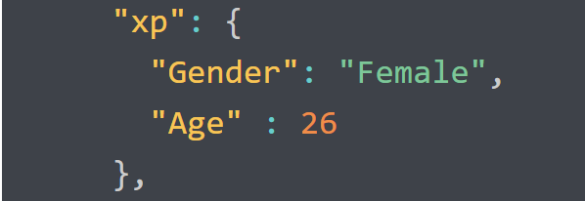Has there been times when you wanted to extend an existing property of a model supplied from third party code and it was a nightmare to integrate? With Four51, it is as simple as adding Key/Value pair to existing model property. This will then automatically be added as an Extended Property for that object in Ordercloud. This makes it effortless to add/extended existing data model.

# Ordercloud Portal

When I think of Ordercloud portal I can summarize it as easy to use and self-explanatory. The UI is simple and uses REST calls to work with data, which again is all JSON. Free to use and documentation covers all basics needed to get started. 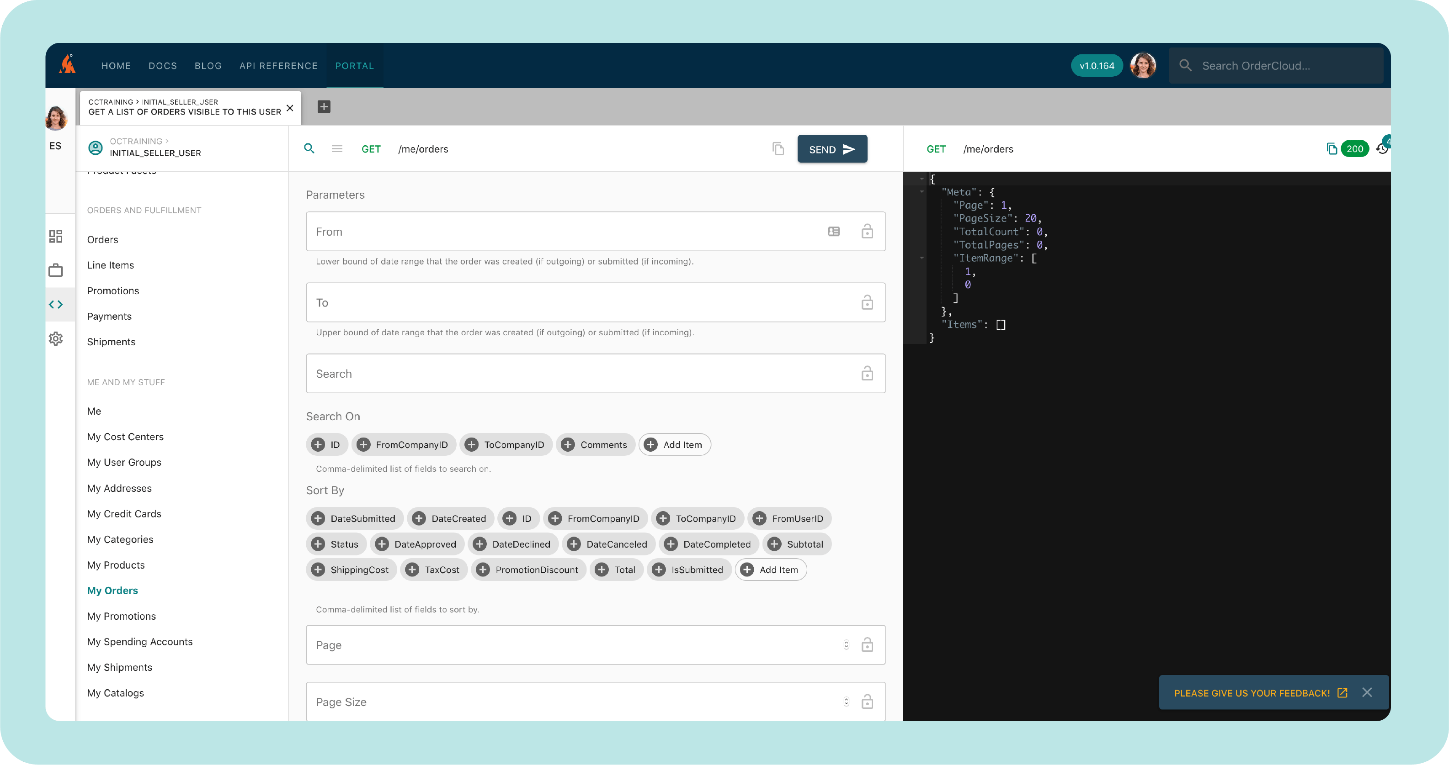

# Postman

I love Postman. It is easy and fast and get the job done. With Four51 being RESTful API and implementing OAuth2.0 for security, Postman setup is quick and simple copy paste of commands once you set-up variables and establish Authentication. Testing and working with data becomes lightning fast after integration.

There are a lot of services to choose from when it comes to eCommerce and Order Management. But for me, Four51 is the go-to service. With its RESTful API, headless approach and effortless integration with other systems and services, Four51 is tough to beat. After all it has been in business for last 22 years.